Data Science Capstone Project
IBM & Coursera
Luqi Wang
1/7/2021

Which major city should you start a delivery business in?

Introduction
Coronavirus disease 2019 (COVID-19) has spread worldwide and it becomes pandemic since December 2019. According to News.google.com, on 1/7/2021, the total confirmed and probable cases are 21,409,444 in the United States. And more than 360,000 people are dead due to the COVID-19. Hospitals are facing shortage of resources, including human resources and supplies, especially in major cities, such as New York, Los Angeles, San Francisco, Dallas and Seattle.
On one hand, businesses are facing significant challenges during the pandemic. On the other hand, many business opportunities appear. Since most states are still in stay-at-home stutatus, delivery businesses, which in the food industry, medical supply industry or shopping industry can take advantage of sat-at-home order. Hoping small business owners find the best city to start their delivery business is the key problem to solve this project. My goal is to analyze hospitals’ locations in five major cities, including New York, Los Angeles, San Francisco, Dallas and Seattle. As a result, an owner can run its delivery business in a selected city and earn more money.

Data Collection and Methodology
The FourSquare API is a best tool to use for collecting data of hospital locations in five major cities.
- Venues channel
- Near query to collect venues
- Category ID (hospital) to set
- CLIENT_ID: 54DYXJOBER2F4X1GZYLKUN1BK5CN5TWVURNKYSAQ052D2M3V
- CLIENT_SECRET:IBWPSNOADLPZXKWVHUGENR5DXH5E0I1BI2TGSXIVXY3OSI4LVERSION
I get 100 venues for each city by using query. The top 100 hospital data are in the result and plot on the map for visualization. After getting geography information, I find a center coordinate of the venues and calculate both the mean longitude and latitude value. The mean distance is the key value that estimates the delivery distance and daily expense.Therefore, by using mean coordinates, it is obvious that we can find a city which can spend less time to reach all hosipitions.

Map Display
- New York: Total number of hospitals in New York, NY is 266. The blue dots show the top 100.
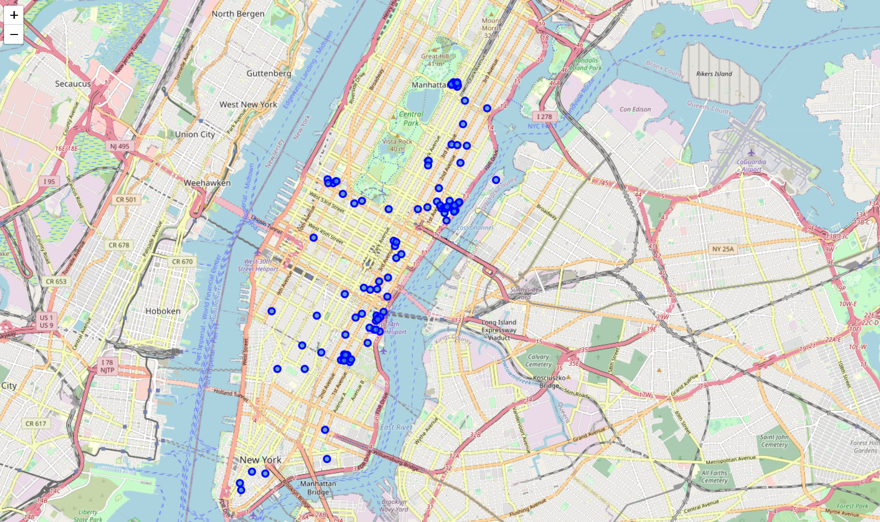
- Los Angeles: Total number of hospitals in Los Angeles, CA is 210. The blue dots show the top 100.
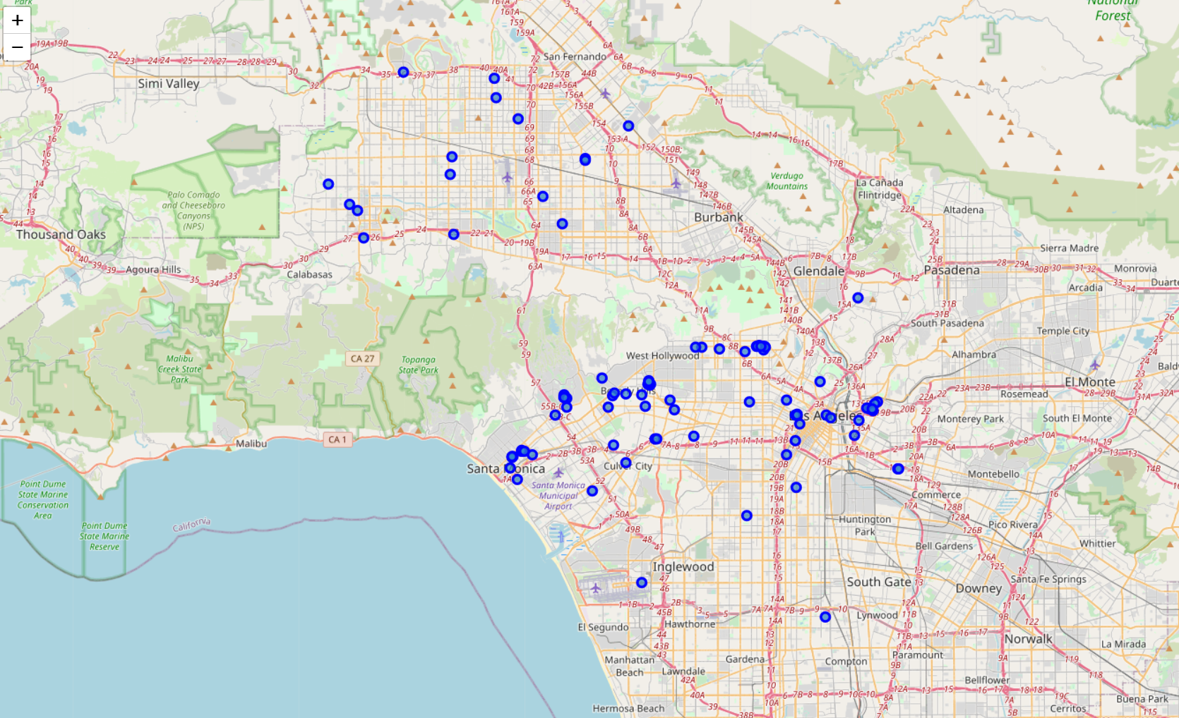
- San Francisco: Total number of hospitals in San Francisco, CA is 186. The blue dots show the top 100.
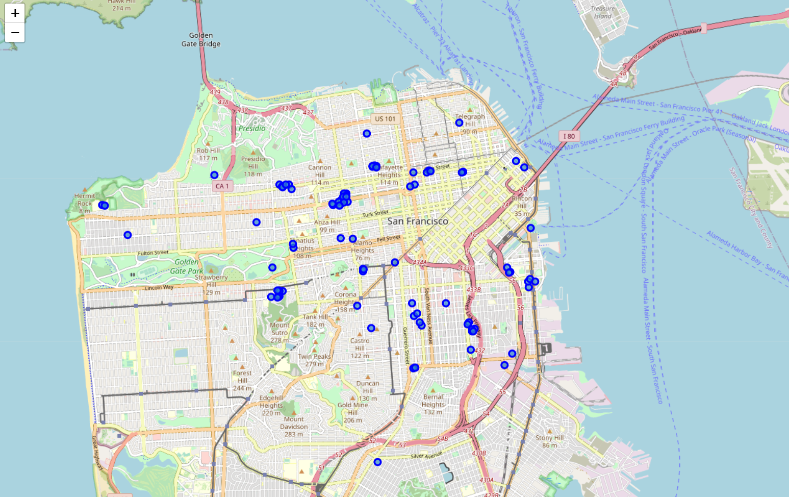
- Dallas: Total number of hospitals in Dallas, TX is 198. The blue dots show the top 100.
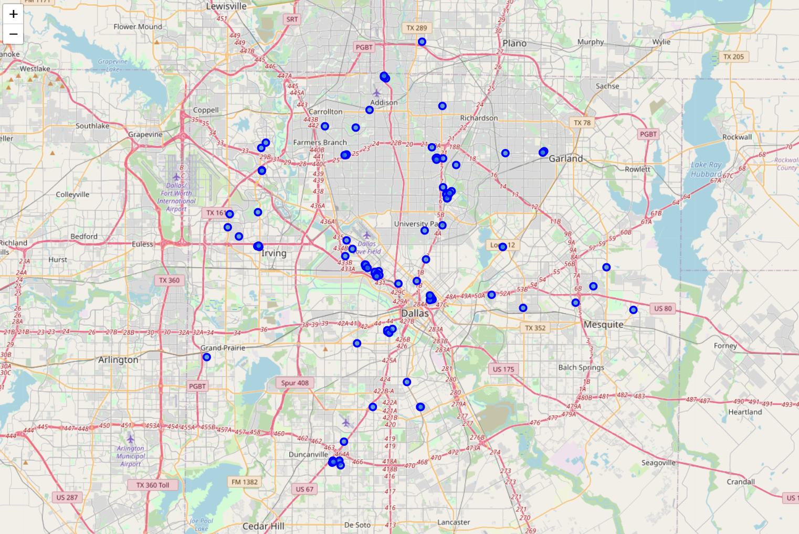
- Seattle: Total number of hospitals in Seattle, WA is 185. The blue dots show the top 100.
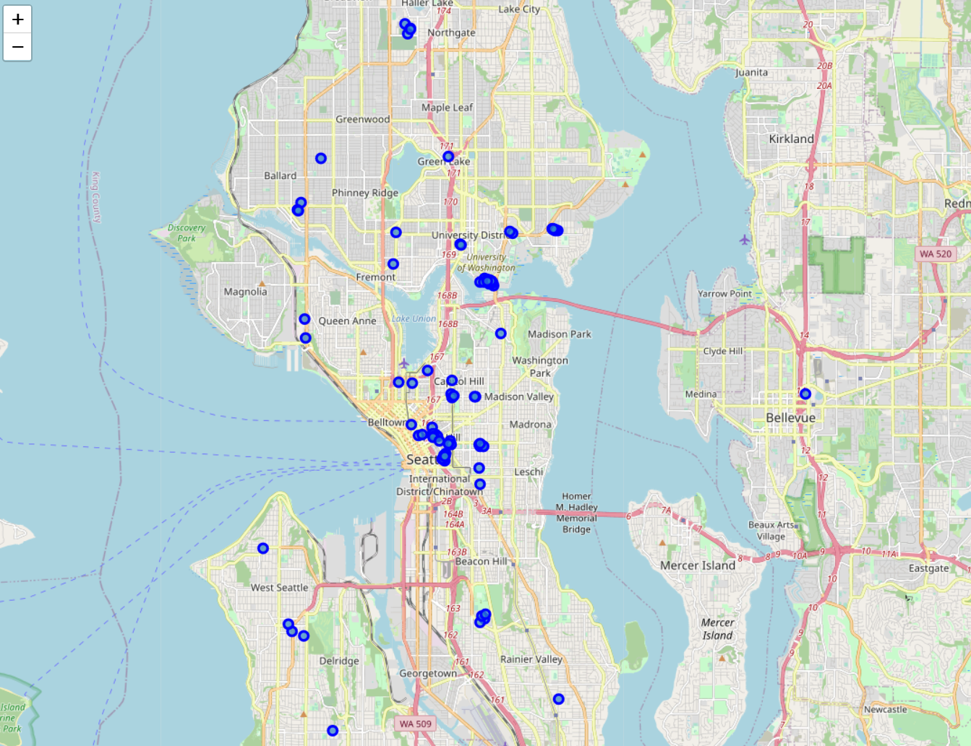

Data Analyze
Calculating the mean coordinate and the mean distance to mean coordinate (MDMC) will help us to find the most dense city which is a better city to start a delivery business.
- New York: MDMC = 0.023630874515147247
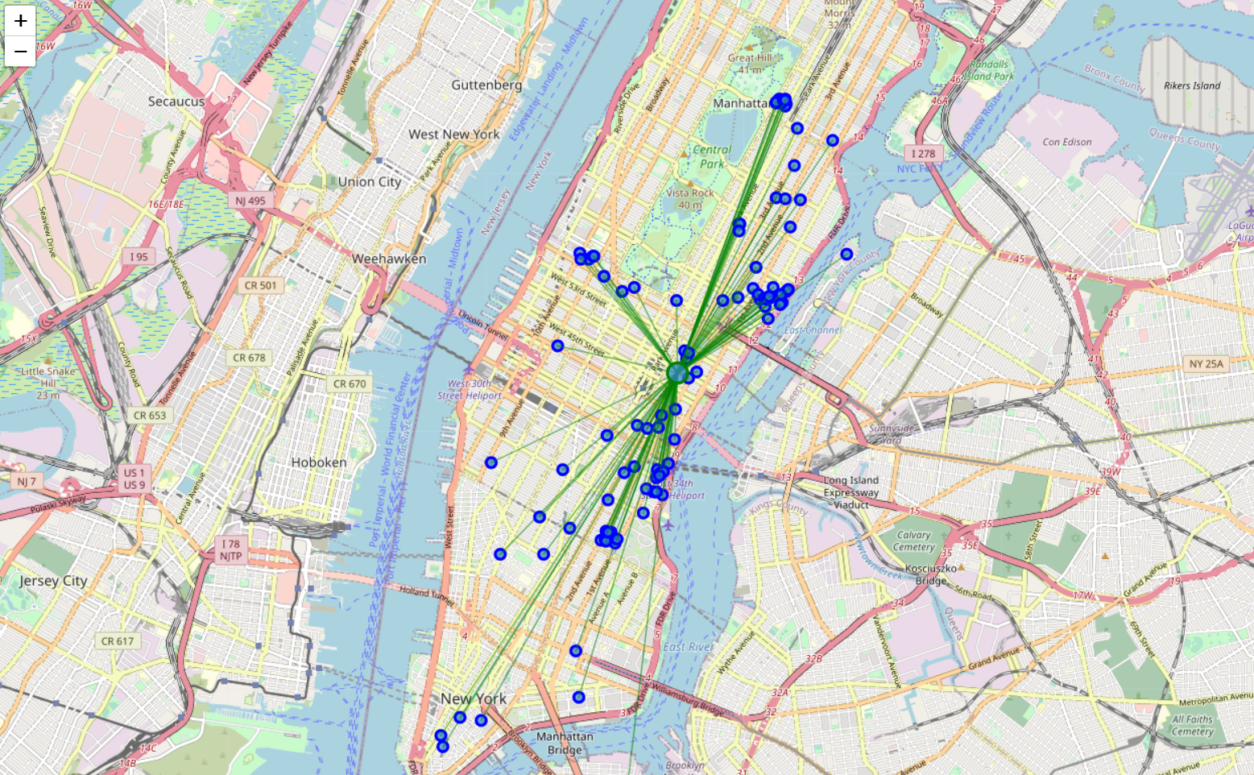
- Los Angeles: MDMC = 0.10869656135179911
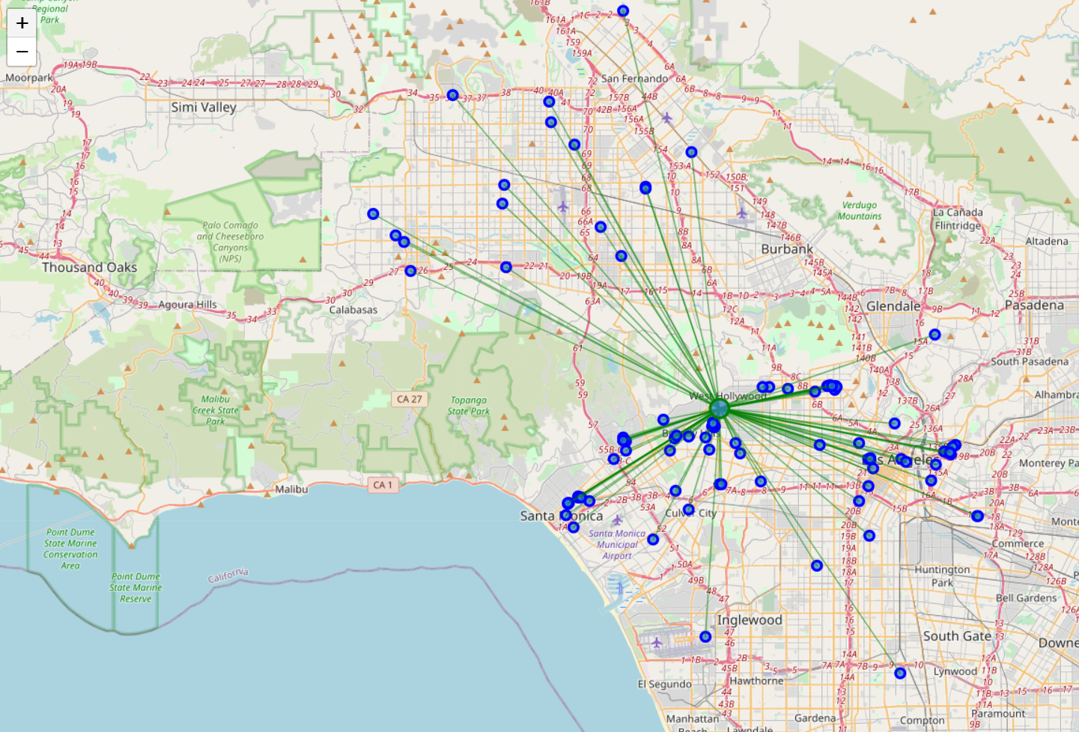
- San Francisco: MDMC = 0.026154080491832876
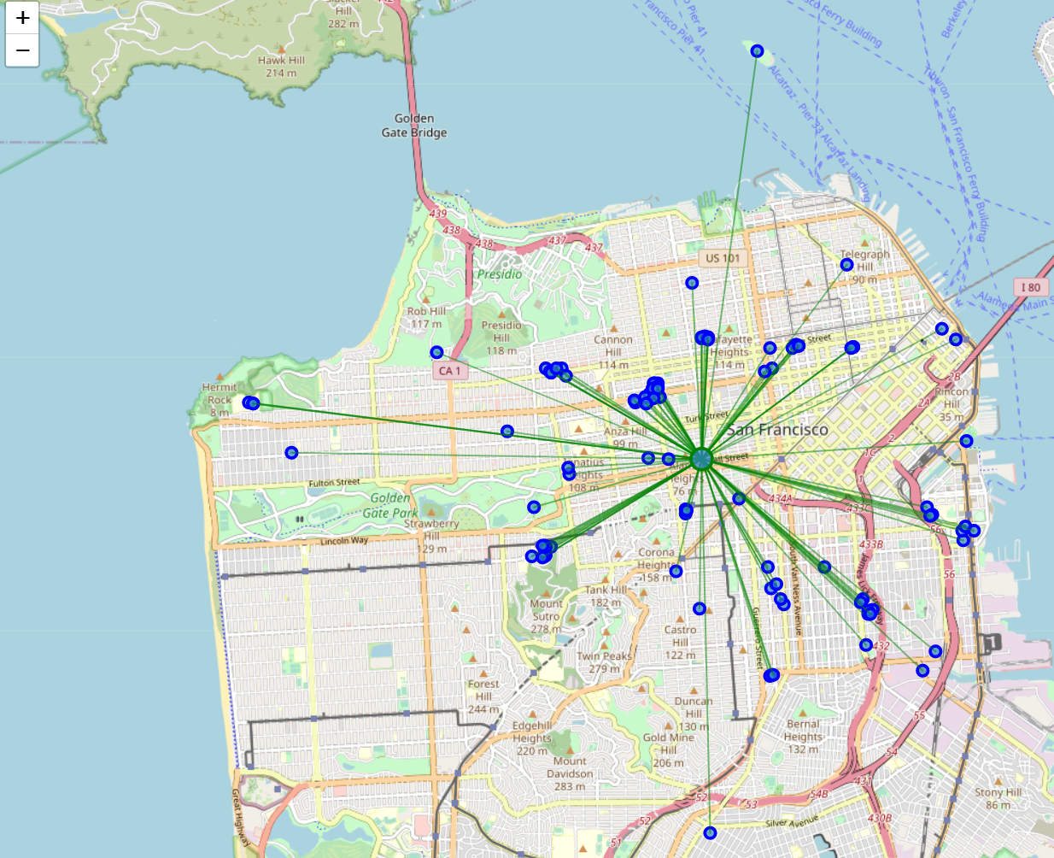
- Dallas: MDMC = 0.10504972567093532
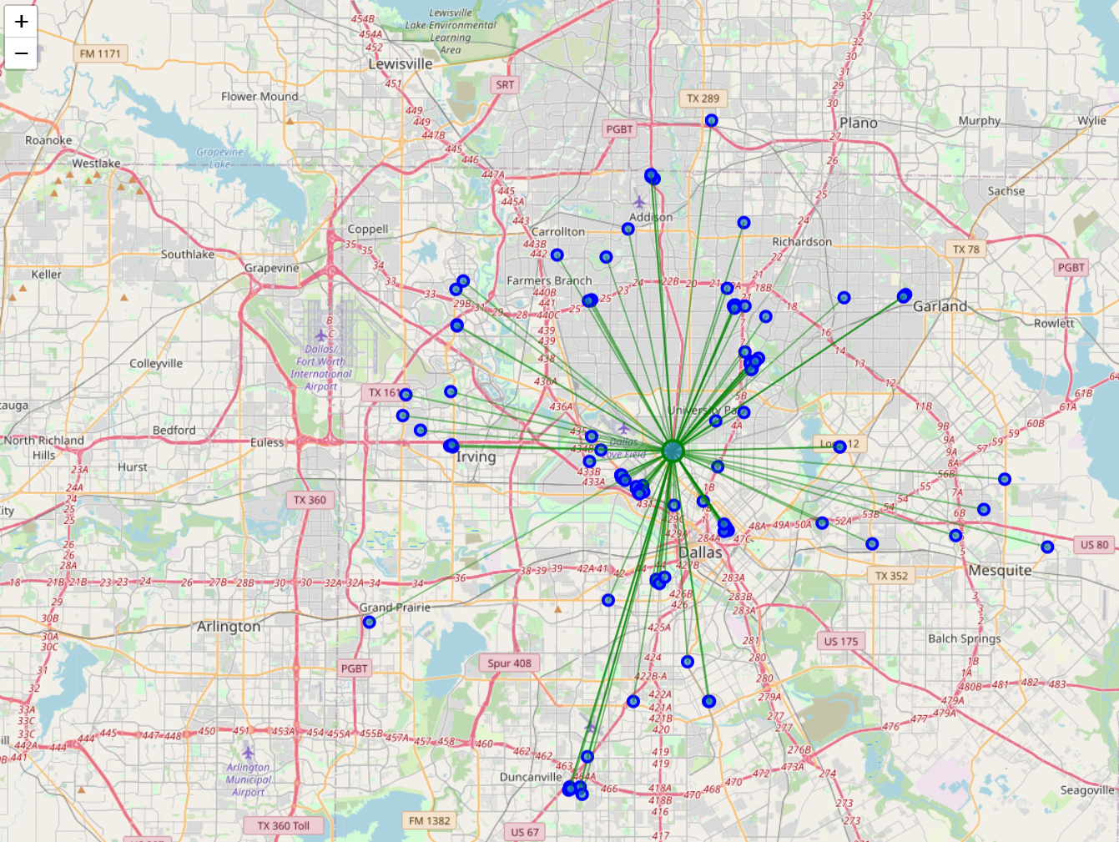
- Seattle: MDMC = 0.03792057043214949
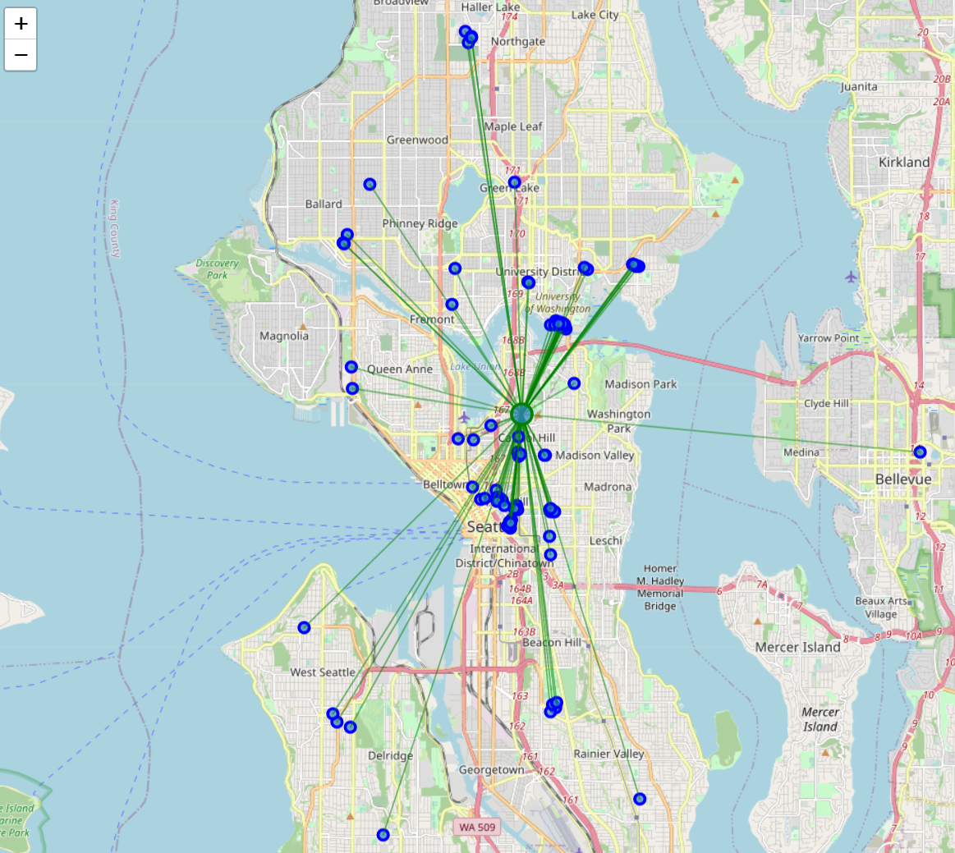
Thus, our sequence is:
- New York, NY,
- San Francisco, CA
- Seattle, WA
- Dallas, TX
- Los Angeles, CA

Conclusion
We know that New York is one of most densely populated cities in the world. By using data science tools we can approve this result again. According to News.google.com, on 1/7/2021, the total confirmed and probable cases are 467，327 in New York City, NY. And more than 25,416 people died due to Coved-19. Small business owners can run their delivery business in New York and it will earn more money due to the short MDMC.

Future Discussion
This model only analyzes the geography information. If we want to do a compenhasize analysis for small business owners, who want to return business filed, we should also add more independence, such as average cost, city traffic and other related issues.

